Andrea Kirwin Artist Bio 2018

“An Earthy blend of Folk, Funk and Soul with an Island Style Roll”

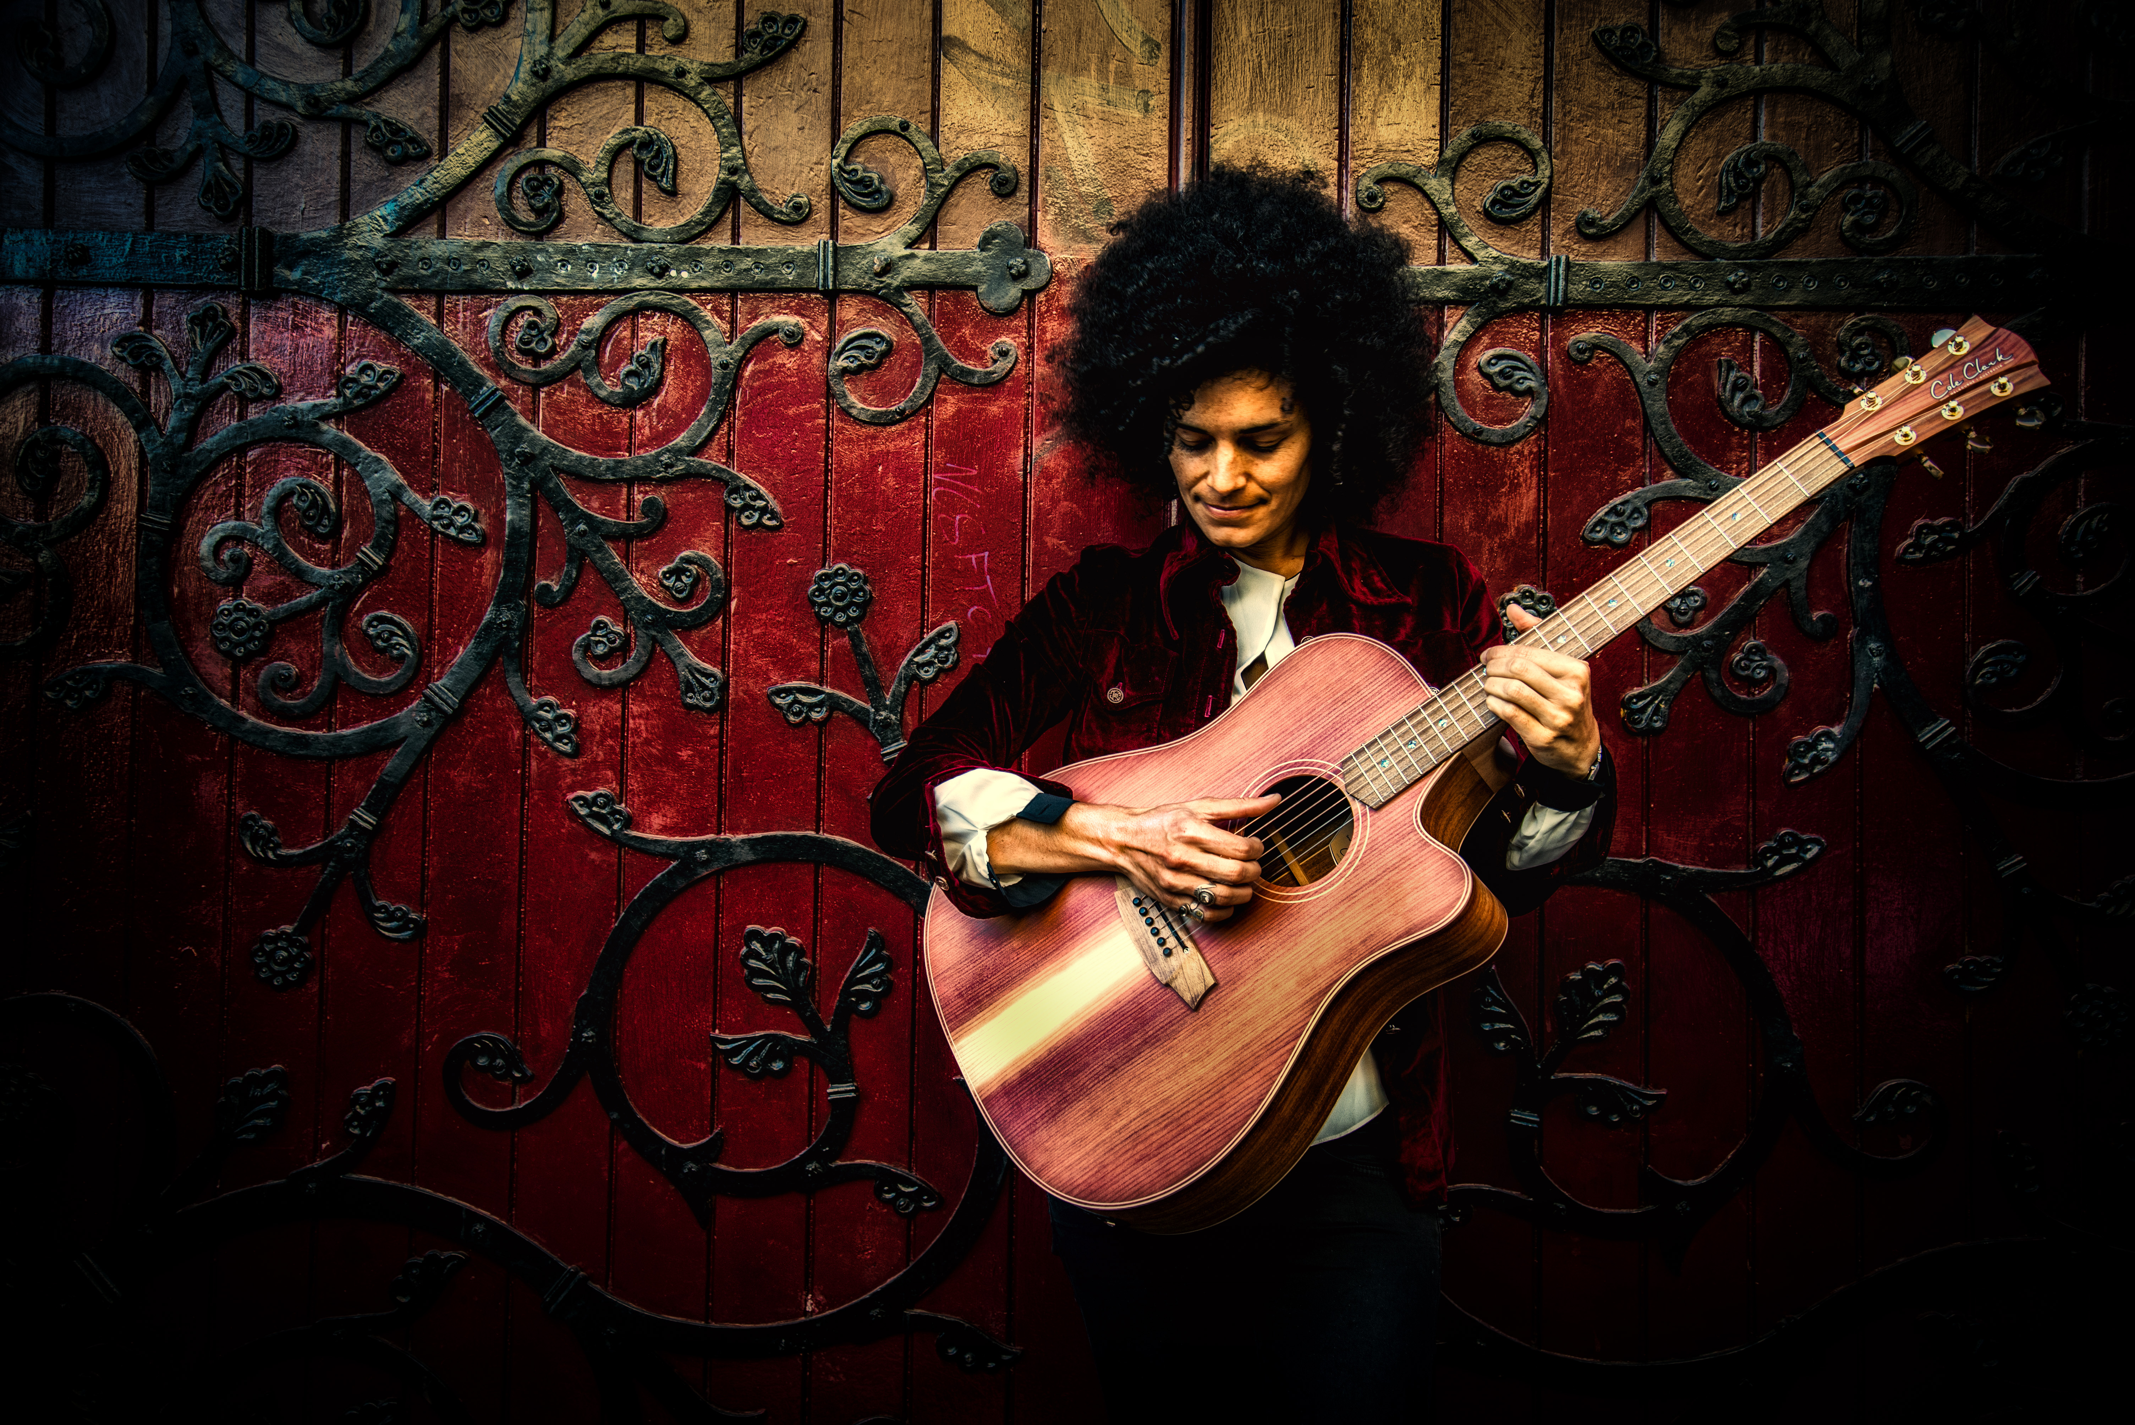

Andrea Kirwin is a singer/ songwriter based on the Sunshine Coast, QLD. Originally from Townsville and the daughter of a Fijian Church minister, Andrea grew up singing three-part harmonies with her siblings. Over the past 10 years, Andrea has travelled the country performing her original songs after picking up a guitar at age 21. She is a Folk Festival favourite around Australia and is a seasoned performer and storyteller. Her style of music can be described as an earthy blend of folk, funk and soul with an island style roll. With a warm and disarming stage presence, Andrea has been steadily building a national following since the release of her debut album ‘From the Ground Up’, in 2013. Since then she has gone on to release two more albums under her own independent record label, Peace Run Records (‘The Story of Us 2015’, and ‘A Quiet Revolution’, 2017). Andrea performs regularly on the Sunshine Coast as a solo artist, and nationally at Festivals with her band of talented gentlemen, Mitch Francis on Drums, Oj Newcomb on Bass and Brodie Graham on Electric Guitar.

FESTIVALS PERFORMED AT IN 2017

National Multicultural Festival (ACT)
Fairbridge Folk Festival (WA)
Wintermoon (QLD)
Palm Creek Folk Festival (QLD)
Echuca Winterblues Festival (VIC)
Sunshine Coast International Readers and Writers Festival (QLD)
Horizon Festival - Dawn awakening (QLD)
Caloundra Music Festival (QLD) *With Thump and Bearfoot
Island Vibe Festival (NSW)

FESTIVALS PERFORMED AT IN 2016

Valley Fiesta (QLD)
West End Festival (QLD)
Horizon Festival (QLD)
Maleny Music Festival (QLD)
Four Winds Festival (NSW)
Majors Creek Folk Festival (NSW)
Quandamooka Festival (QLD)
Bigsound Music Expo (QLD)
International Readers and Writers Festival (QLD)

CAREER HIGHLIGHTS

Woodford Folk Festival Artisan Weekend Song writing Masterclass (2018)
Cole Clark Guitars Endorsement (2017)
Representing multicultural Artists from QLD at Bigsound QLD (2016)
Performing at the Woodford Folk Festival (2015, 2013, 2011, 2009)
Receiving a Regional Arts Development Fund ($6000) grant to
produce 2nd Album, 'The Story of Us' (2015)
4 songs from 'The Story of Us' Highly commended in
Queensland Music Awards 2016.
3 East Coast Australian Tours

Peace Run Records

In 2009, Andrea founded her own independent Record Label, Peace Run Records and produces and releases her own music. She also mentors and supports up and coming artists to help them gain a footing in the music industry.

For more information on Tour Dates and Music News please visit:

www.andreakirwin.com

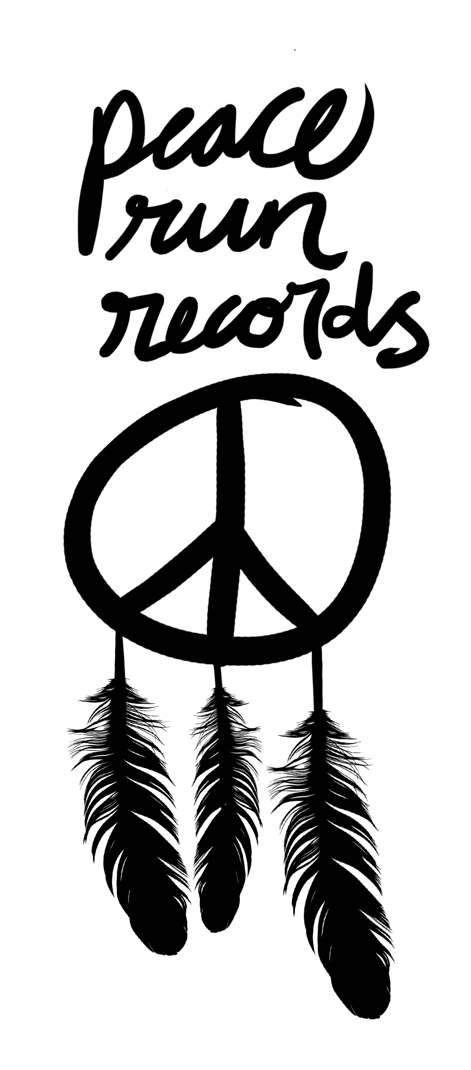
Andrea Kirwin Music Links.

Website:
www.andreakirwin.com

Youtube Videos Links:

“Higher in Love”, Official Music video 2015
https://www.youtube.com/watch?v=MZXUhwdx490

“Mary Go Round”, Official music video 2013
https://www.youtube.com/watch?v=i7Rl2oxIfTM

Other music Links:

http://onepagelink.com/andreakirwin/

https://www.triplejunearthed.com/artist/andrea-kirwin

https://soundcloud.com/andrea-kirwin

http://andreakirwin.bandcamp.com

