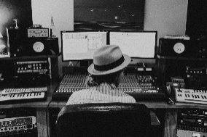
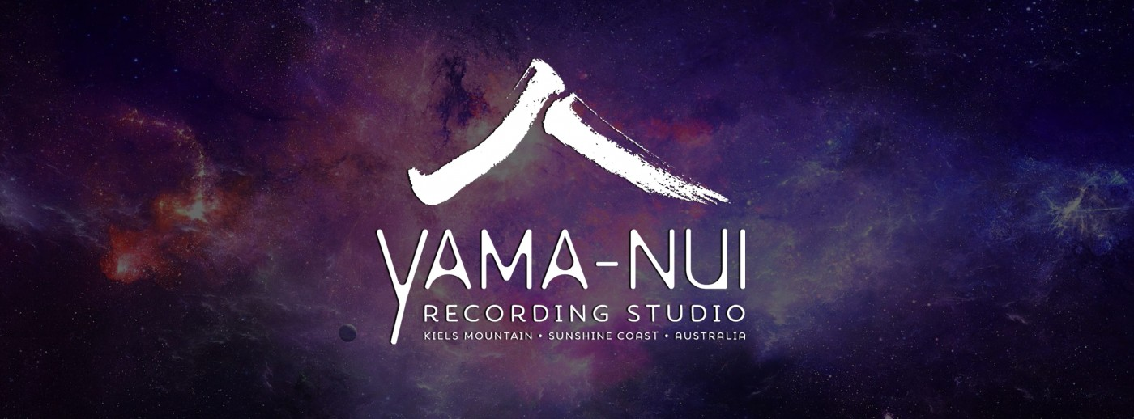
Paul Bromely Letter of Confirmation and Support
Head Producer and Engineer at Yama-Nui Recording Studio, Kiels Mtn, Sunshine Coast.
April 10, 2021

To the PPCA grants committee,
I am writing to express my support for Andrea Kirwin’s proposal to record her new album, ‘Queen’s Land’ at Yama-Nui Recording studio with myself as the Sound Recordist and Mixing Engineer.
I have thoroughly enjoyed working with Andrea before on her last album ‘Bloom’ and on past projects such as the live band album for her Carol Lloyd Award application in 2019. Andrea is not only a talented songwriter, arranger creating high quality music, but an inspirational and activated member of our local community who is in my opinion an ideal candidate for your support through this $15,000 grant. I have heard her ‘Queen’s Land’ album demos and attended a rehearsal with Andrea, the King sisters and Claire Evelynn and immediately expressed to Andrea how keen I am to be involved in this project. These new works definitely leave a lasting impact on the listener and the strings and harp really accentuate the sophistication and grace these talented Women embody.
I wish Andrea all the best in her application for a grant to record this album and have absolutely no hesitation in supporting this application in full. I can’t wait to help them capture these songs and for the opportunity to work with Andrea again in the near future. If you have any questions feel free to contact me and I’ll be happy to assist you.
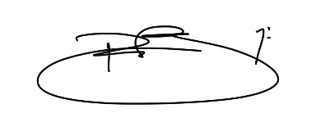
Thank you
Paul Bromley
0407147568
paulieb@me.co

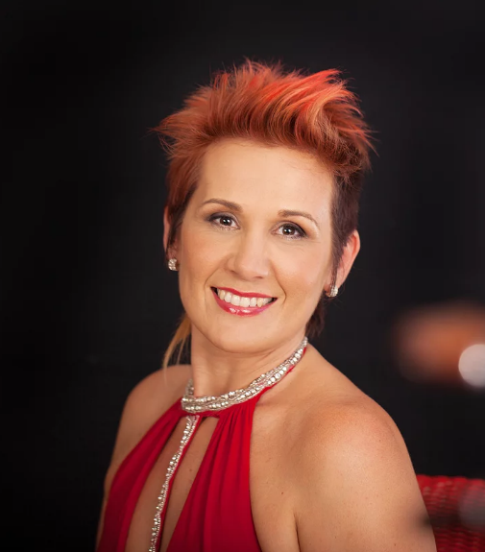
Cello Dreaming
Louise King – Cellist

To whom it may concern,
I am writing in support of Andrea Kirwin’s grant application to record her original album, ‘Queen’s Land’. I have recently had the pleasure of touring with Andrea for a run of shows in regional QLD thanks to an ARTS QLD grant in 2020 and thoroughly enjoyed performing with her also at the Woodford Folk Festival at Bushtime in December 2020. She is a wonderful person and a hard working performer who has been dedicated to her artistry for many years since I first performed on her debut album back in 2013.
I would like to confirm my availability for the later half of 2021 to spend 2 days recording live at Yama-Nui recording studio and I look forward to working with Andrea, Sarah and Claire on creating a beautiful album. Andrea is very deserving of a grant such as this, she gives a lot of her time to her community and is always ready to support other’s projects. She is a gifted songwriter and fantastic performer and I wish her every success in her application.

Sincerely,
Louise King
Eudlo, Sunshine Coast

River Suite Orchestra
Sarah King 8 Dalpura Street Buddina,
QLD 4575 Ph: 0408 633250
Email: sarah@riversuiteorchestra.com.au
Web: www.riversuiteorchestra.com.au

12th April 2021
Letter of Support: Andrea Kirwin The Grants Officer,
I am writing in support of Andrea Kirwin’s grant application. The development of strings throughout Andrea’s latest body of work, ‘Queen’s Land’ emerged through the opportunity to perform live at ‘Bushtime’ a new performing arts initiative created by the iconic Woodford Folk Festival in response to the Covid pandemic. I had the pleasure of writing and performing the string arrangements for this performance on the back of previous work with Andrea on her fifth studio album ‘Bloom’. Recorded at world-class Yama-Nui Recording Studio’s on the Sunshine Coast, Andrea’s creative project ‘Bloom’ provided artists and musicians opportunities to work and collaborate with leaders in the industry, at a time when the Covid pandemic decimated the music scene globally. Supporting artists such as Andrea Kirwin is vital as the industry emerges from the pandemic and finds ways to move forward in the ‘new normal’. The proposed application for Andrea’s new project “Queen’s Land’ will foster opportunities and outcomes to build audiences, share and deliver brand new work with a socially collective purpose. I am thrilled to be asked to arrange strings for ‘Queen’s Land’, as I value the opportunity to collaborate as an independent artist and highly regard Andrea’s work and creative practice.
Warm Regards,
Sarah King

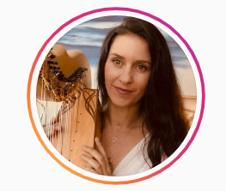

Claire Evelynn Harp
Letter of Confirmation for Andrea Kirwin

Hello, I’d love to express my support for Andrea Kirwin’s album recording of ‘Queen’s Land’. I am honoured to be a part of the project and am available for rehearsals, recording and performing the album in late 2022 and beyond. She writes beautiful songs and this album is going to be something special. Over the years I’ve witnessed her grow as an artist and her arrangements are hitting a new level of professionalism and depth. We performed together at Woodford Folk Festival and it was a magical experience. The strings and harp sounded so beautiful supporting Andrea’s voice and guitar. I look forward to hearing how the grant application goes and wish her luck!
Warmly,
Claire Evelynn
claire.anwen.evelynn@gmail.com

